Student’s name | …………………………………………………….…… | Grade | 4
Subject | Computer | Week No. | 9
Lesson Title | Variables | Unit
Worksheet No. ( 9 )

write the correct name of each part.

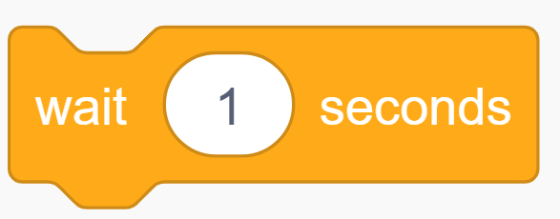

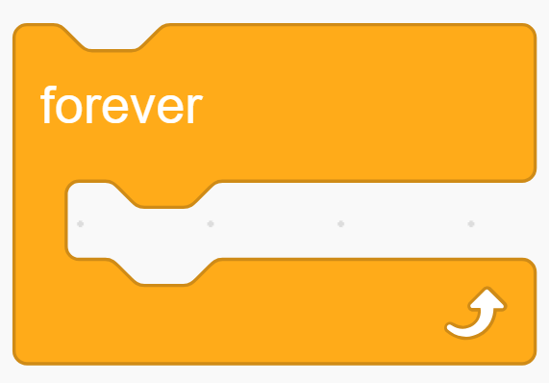
RAM
Forever
Turn
Clock Timer
Wait
Good Luck

